Antarctic Research Voyages - RV Tangaroa

Expression of Interest for Supplementary Science

Voyage January/February 2023 (Exact Dates to be determined)

Introduction
Planning is to commence for RV Tangaroa to undertake a 35 day voyages to the Antarctic/Ross Sea sector in 2023. In July 2019 an expressions of interest (EOI) call was released, for science onboard two Antarctica voyages planned for 2021 and 2023. EOI’s were assessed and a voyage plan was produced for a 2021 voyage which has been successfully completed. This was peer reviewed by Mike Double from AAD. A second tentative voyage plan based on the EOI’s received was also produced for the 2023 voyage. It has been some time since this tentative voyage plan was developed and science requirements have shifted since the first EOI call. Hence this call for supplementary science for the 2023 voyage. There are certain objectives from the first EOI call retained in the 2023 voyage plan that are critical such as retrieving the moorings deployed in the 2021 voyage, and science that was allocated vessel time that is still strategically relevant. This formed the basis for the attached draft voyage outline plan and route. This EOI is a call for supplementary science that may be conducted on this voyage. As a guideline, applicants should consider science that can be conducted within the approximate location of the voyage track and working area. There is capacity for up to 8 scientific personnel. It is anticipated that there may be up to seven days available in the voyage programme, however the exact amount of time available will have to be worked out with all the other science requirements. Applicants will need to propose EOI’s that are scalable. Additional equipment deployments/research objectives will need to integrate well with current planning as per the attached Concept Voyage Programme. This research shall already be funded or have a good chance of funding by the voyage date, for the equipment required during the voyage, the training and personnel required for the voyage, and for publishing any science conducted.
Currently planned operations and technical skills include the following:
- Mooring deployment and recovery
- CTD deployment for physical oceanographic parameters
- Water sampling (CTD and underway system) for microbial, biogeochemical and trace metal analysis
- Zooplankton sampling
- Seafloor video camera (towed and small ROV)
- Multibeam bathymetry mapping
Expressions of Interest (EOIs) for supplementary science are sought from the New Zealand science community. Preference will be given to projects that meet New Zealand’s current Antarctic/Southern Ocean research strategies and priorities (see below).
Antarctic Working Group
It is expected that a number of proposals will be received. As with previous years an Antarctic Working Group of key stakeholders will be formed and responsible for assessing the EOIs and developing a focussed coherent voyage programme. The final objectives and plans for the voyages will be peer reviewed for science excellence and submitted to the Tangaroa Reference Group (TRG Group) for final approval.
Voyage Objectives
The voyages are to support project activities funded by government stakeholders. Applicants must be prepared to have scientists at sea for the full voyage period. Voyage objectives will be determined by the Tangaroa Antarctic Working Group, based on the EOI applications received. These voyages are intended to be collaborative. While it is likely that an array of scientific objectives will be received, the Tangaroa Antarctic Working Group will aim to create an integrated programme of research, incorporating where possible requests for opportunistic data collection, both in transit and within the study region(s).
Relevant Science Strategies & Priorities
NZ’s relevant Antarctica interests include:
- Scientific research - supporting, and where appropriate leading, high quality scientific research in the Antarctic and the Southern Ocean.
- Scientific research and monitoring supporting the Ross Sea MPA.
- Biodiversity protection - conserving, protecting and understanding the biodiversity of Antarctica and the Southern Ocean, particularly the Ross Sea region. This includes promoting, protecting and managing representative special areas and enhancing biosecurity.
- Conservation - managing marine living resources of the Southern Ocean, and in particular the Ross Sea, in a sustainable way; working with CCAMLR and the Antarctica Environmental Protocol to support strong environmental standards and sustainable economic benefits.
- Environmental stewardship - demonstrating and advocating for best practice in environmental stewardship and all other activities throughout Antarctica, particularly in the Ross Sea region.
The Draft New Zealand Antarctic and Southern Ocean Science Strategy 2021-2030.
Other key documents/initiatives outlining research priorities that should be considered include:
- The research objectives and themes of the newly established Antarctic Science Platform hosted by Antarctica NZ.
- The Deep South National Science Challenge Research Plan.
- A plan for research and monitoring in the Ross Sea region, in association with spatial marine protection - prepared jointly by New Zealand and USA representatives and submitted to CCAMLR in 2013 in support of the Ross Sea Region Marine Protected Area proposal, and provides guidance on the research the New Zealand government has identified as high priority to support its objectives in international forums. Note that it is intended that this draft document will be substantially revised and updated during 2017 (including a dedicated workshop for that purpose). Objectives for the MPA remain as described. See https://www.mfat.govt.nz/en/environment/antarctica/ross-sea-region-marine-protected-area for relevant science documents and the proposal.
Voyage Requirements
Those submitting an EOI should note that the following resources, equipment and activities will need to be covered by the applicant, along with any associated costs:
- All science/survey personnel directly relevant to your specific objectives.
- Equipment (note that NIWA owned science equipment may be available for hire) and project specific consumables for the voyage.
- Comprehensive Medicals (contact NIWA for further detail) and basic marine survival training (STCW) for all your science/survey personnel participating on the voyage.
- Any additional vessel crew required (Dynamic Positioning operators if required, additional deck crew for labour intensive voyages) and extra fuel used if the vessel is required to use its Dynamic Positioning System for significant periods.
- All your own project logistics including travel to and from the vessel for science/survey personnel and loading of equipment.
- All project specific ship to shore satellite phone communications by science/survey staff during the voyage.
- Insurance for equipment loss or damage during the voyage (NIWA will not cover liability for any third party equipment lost or damage during the voyage).
- NIWA technical personnel required to run vessel sounders (e.g., EM302/TOPAS etc) if required.
- Production of project specific Health and Safety Plans, JSEA’s and SOP’s for any update to procedures or new procedures.
- Any required HSE Audit or due diligence exercises that are required for the specific project or by the applicant or their collaborators.
- Parties are required to adhere to NIWA’s Health & Safety requirements. This may require medicals or training by science/survey personnel in advance of the voyage.
- The requirement to read, understand and sign NIWA’S Acknowledgment of Risk and Safety Duties Agreement.
- Obtaining required consents, permits and permissions for your specific objectives.
- Data management – The applicant must define the data streams from the voyage and intended ownership and access of the data, which must be consistent with the New Zealand Government Open Access and Licensing Framework (NZGOAL).

Applicants should contact Rob Christie at NIWA directly (Tel: 043860881 and e-mail: rob.christie@niwa.co.nz) for further information on logistical requirements and costs.
EOI Submission Date
All EOIs must be submitted to NIWA (Rob Christie, rob.christie@niwa.co.nz) by 1 October 2021 using the EOI template provided below. Please inform NIWA if the proposed research within your EOI is dependent any research fund application yet to be granted. EOIs are not expected to be longer than 2-3 pages. Further information will be sought should your project be included in the voyage programmes.
EOI TEMPLATE
Proposal Title
Organisation
Project Leader | Name and brief outline on vessel going experience.
Address
Phone
Email
Proposed Project Objectives  Describe the outcome to be achieved and why these are required/relevant to NZ’s Antarctic/Southern Ocean Strategic Directions | Please bullet point the following:  - Overall voyage science objective(s)  - Strategic rationale
Vessel requirements | Note: this will be a collaborative voyage so please identify logistical requirements on the vessel to undertake the proposed project (e.g., personnel, vessel sampling time, deck space, laboratories, winches etc). Identify if these can be run in parallel with any other activity.
Proposed Project Methodology

Consents, Permits and Permissions
Identify any anticipated specific consents for the proposed project.
International collaboration and support
Describe any international collaboration associated with the science and/or voyage, including in kind/funding support.
Funding
Provide estimate of funds available to support the project.

CONCEPT VOYAGE PROGRAMME – TAN2301

Voyage Code: TAN2301
Voyage Leader: Joshu Mountjoy
Project title: TBA
Vessel: R.V. Tangaroa
Area: Ross Sea sector of Antarctica and the Southern Ocean (CCAMLR subarea 88.1)
Period: XX January – XX February 2023
Mobilisation: X-X January 2023
Demobilisation: X-X February 2023

EOIs for the 2021 and 2023 voyage were submitted in 2019 and form the basis for this Voyage Concept following discussion with ASP and RossRAMP leaders. This Voyage Concept Plan sets out the following:
- Timeline for the 2023 voyage
- Currently committed resources to the voyage and available capacity
- Anticipated working area/voyage track

Currently planned operations and technical skills include the following:
- Mooring deployment and recovery
- CTD deployment for physical oceanographic parameters
- Water sampling (CTD and underway system) for microbial, biogeochemical and trace metal analysis
- Zooplankton sampling
- Seafloor video camera (towed and small ROV)
- Multibeam bathymetry mapping

TAN2301 timeline

July 2021 Identification of additional onboard capacity and call for additional interest
October 2021 Revised voyage concept circulated for comment
February 2022 Voyage objectives and participants identified
June 2022 Required permitting submitted
July 2022 Draft voyage programme circulated for comment
January 2023 Voyage commences

TAN2301 capacity

Total science berths: 22 (This assumes that no trawling is taking place as this was only anticipated for the 2021 voyage in the 2019 planning process)
Committed known funding: 14 berths
Remaining capacity: 8 berths

Voyage plan preliminary concept
The 2023 voyage is proposed to follow directly on from some of the science objectives of the 2021 voyage. The overall plan and focus areas is predicated around the turn around of existing moorings, and the ASP focus on near coastal ecological sites. This includes the region of the Drygalski Trough outflow at the northern continental shelf break, and the western Ross Sea shelf from Cape Adare to the Drygalski Ice Tongue (see planned voyage track Figure 1).

The voyage will start from and return to Wellington, New Zealand. Tangaroa will proceed directly to the northern boundary of the Antarctic Treaty Area at 60°S.

Once in the Antarctic Treaty Area, the first voyage objectives will be to recover and re-deploy passive acoustic moorings on the Pacific Antarctic Ridge Recover and Scott Seamount. The vessel will then complete a mooring recovery/re-deployment at Iselin Bank and CTD transects. From there Tangaroa will transit towards Cape Adare (ice permitting) where the oceanographic moorings in the vicinity of Cape Adare will be recovered/re-deployed. The remainder of the voyage will be focused around the coast and shelf region in the western Ross Sea. The specific work to be carried out in this region is yet to be determined.

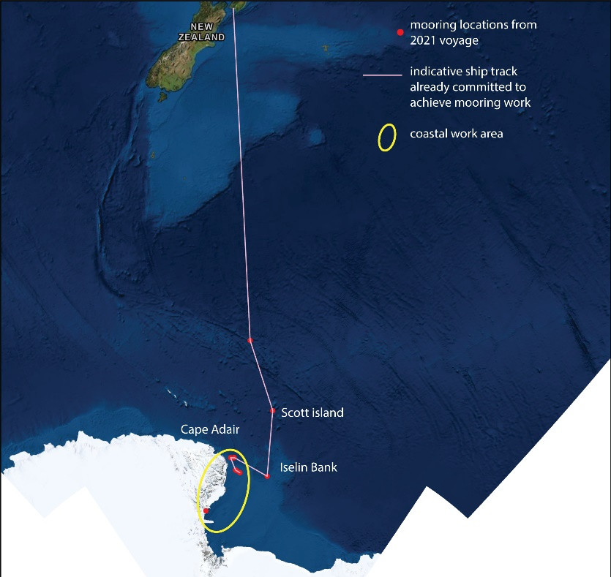
Figure 1. TAN2101 planned voyage track.

