MEDIA RELEASE

28 MAY 2015

Historic research data discovered
A climate scientist at NIWA’s Lauder Station research centre in Central Otago has stumbled across the oldest known mid-infra-red spectra – scientific readings taken 30 years ago on 29 May 1985.

Atmospheric technician Dan Smale rediscovered the data while archiving and updating historical archives at the high-country observatory, where world-class atmospheric data is collected and analysed to add to knowledge about global climate change.

“Molecules in the atmosphere absorb sunlight. Each molecule -- such as water vapour, ozone, carbon dioxide, methane -- has a different absorption ‘fingerprint’ that is measureable,” he said.

Infra-red spectra measurements are collected by an instrument called a Fourier transform interferometer and profile the sunlight-absorbing molecules in the atmosphere.

“By measuring these absorptions we can say how much of a molecule is in the atmosphere,” says Mr Smale. “This is a well-established technique called spectroscopy.”

Spectroscopic gas measurements can be made in the UV, visible and infrared wavelength regions. Many gases of interest in the atmosphere absorb infra-red light, so we measure in the infra-red.

In the 1980s infra-red measurements revealed the gases responsible for destroying ozone. There was international concern over the discovery of a hole in the ozone layer. Measurements made at Lauder and Scott Base by NIWA’s predecessor, the Department of Scientific and Industrial Research contributed to international research on the implications of the ozone hole.

Until this most recent find, NIWA had raw spectra data back to 1990. The find of this additional data extends the spectra record back another five years.

“By repeatedly taking infra-red data over time and analysing it to measure gas amounts, we can see how gas amounts change over time,” Mr Smale says. “It’s an exciting extension of climate science knowledge.”

Over the past three decades there have been three major changes in atmospheric research, Mr Smale says: the science focus, a greater multi-disciplinary approach to research and the technology.

The focus has shifted from ozone-hole research towards greenhouse gas and pollutant gas measurements. The same instrumentation and analysis methodologies are used -- ozone and ozone-destroying substances are still measured -- but now the scope has expanded and more molecules are analysed.

There is now more collaborative work with atmospheric chemical modellers, comparing measurements to model simulations to understand the atmosphere better. Also, the measurements are compared with increased numbers of satellite measurements.
But by far the biggest change is in the technology used. While the fundamentals of the instrumentation are the same, there is a huge change in the amount of measurements, and the way they are collected.

New instrumentation is more automated and has fewer faults, says Dan. In 1985 individual measurements were stored on a 180-kilobyte 5.25-inch floppy disk; now all measurement data is stored on 1 terabyte hard drives. The instruments in 1985 collected only raw data; now computers attached to the current instruments handle the data 1000 times faster.

ENDS

Image: NIWA Atmospheric Technician Dan Smale

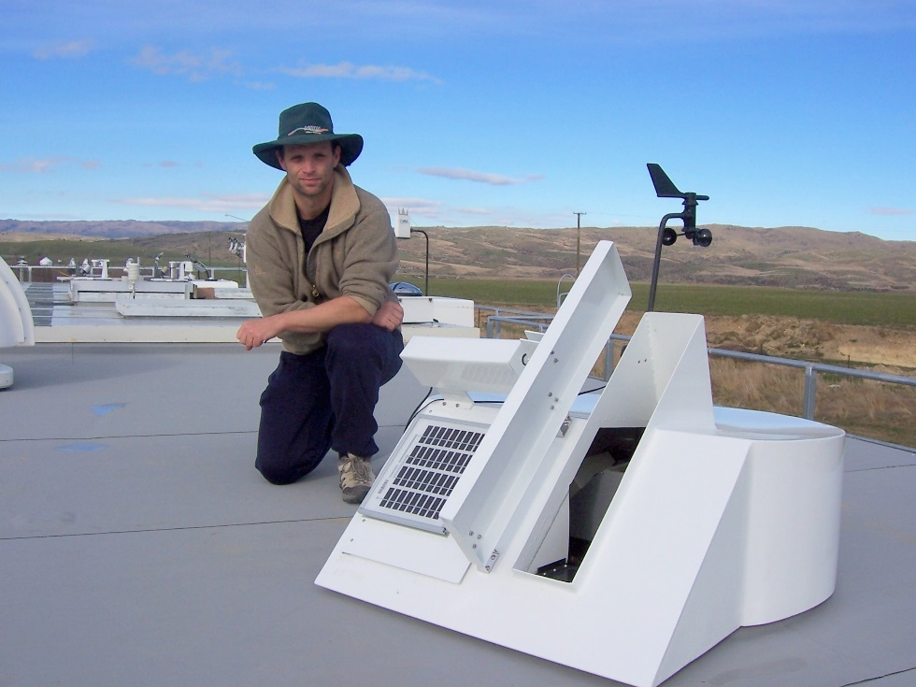

THEN AND NOW (over page): Old data stored on floppy disks 30 years ago adds to research material gathered
by more modern techniques.
